**Gregory Oswald**

**Cluster Head DACH (Franke Home Solutions)**

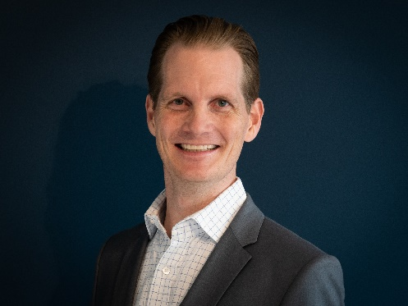Gregory Oswald is the Cluster Head for DACH since February 2022, where he leads the commercial organization across the Austrian, German, and Swiss markets. With an extensive background in commercial operations, marketing, and product management, Gregory brings a wealth of experience to his current role.

Gregory embarked on his journey with Franke in 2019 when he assumed the position of Chief of Staff to the CEO of the Franke Group. Since then, he has steadily advanced in his career within Franke, holding various key positions, including VP of category management, leading up to his current responsibilities.

His multifaceted expertise in sales, marketing, and product management has shaped him into a well-rounded professional, ready to lead the transformation of the DACH cluster into a leading system provider within the kitchen environment.

After earning a degree in Business Administration and completing a Master’s program in Strategy and international Management, both from the University of St. Gallen and the Nanyang Business School in Singapore, he started his career as a Strategy Consultant at Arthur D. Little, where he gained extensive expertise in the fields of strategy & business development and M&A related activities.

Subsequently, he joined Sonova, an internationally leading company in the hearing aids industry, where he applied and further developed his know-how in the field of business development and M&A.