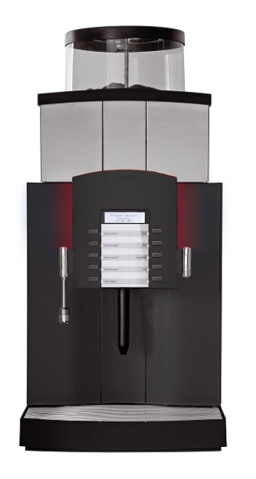
Feature over view
Franke Spectra X-XL – Filter coffee automat, 1 powder dosing unit for ground coffee, hot water spout, control unit Basic or Vetro 8, fixed water connection

Microprocessor-controlled filter coffee automat with 1 powder dosing unit for ground coffee for the preparation of larger quantities for brewed coffee. Dosed or non-dosed dispensing of hot water is possible, simultaneous with the dispensing of coffee, through a separate spout.

Technical data

Hourly capacity: Brewed coffee: 369 cups*
Hot water: 290 cups*

Connected load: 400 V 3LNPE 9300 W, 16 A, 50/60 Hz (1 boiler)

Energy loss: 3.467 kWh/24 h*

Water inlet: Cold water connection: G 3/4" external thread
Water pressure: 300 to 1000 kPa (3.0 to 10.0 bar)
With Brita water filter: 300 to 600 kPa (3.0 to 6.0 bar)
Inlet hose: Ø 6.4 x 1500 mm (brewing water)
Inlet hose: Ø 12.0 (Ø 9.5) x 2000 mm (rinsing water)

Water outflow: Drainage connection: Grounds separator on funnel trap Ø 50 mm, ventilated.
Waste-water hose: Ø 40 for grounds separator

Weight: net to max. 49 kg

Dimensions: Width: 400 mm
Height: 867 mm (with standard base)
Depth: 586 mm

Noise emission: Acoustic pressure: < 70 dB (A)

Approvals: CE

*Output per hour and energy loss information are according to DIN18873-2

Version
Housing parts and product container are manufactured from low-maintenance plastic, the drip grid is made of stainless steel. All safety-relevant components are certified by the respective testing authorities. Housing colours Black Line (high-gloss black) or Silver.

Control unit basic
10 individual programmable product buttons. 4 buttons for brewing steps and 6 buttons for product choice. The dispensing quantities are freely programmable – for a cup, mug, and small or large jugs. The product label via a customizable drawer slide. The user interface, the setting and the status function displays take place over 3 lines and 20 characters comprehensive graphic LCD. (Above) selected products are displayed by means of the product LED's and on the display.

Control unit Vetro 8
8 large, individually programmable product buttons (capacitive) on unbreakable acrylic glass panel. 4 for the choice of brewing stage and 4 for the choice of product. Individual assignment for the dosed removal of cups, jugs, pots, jugs, etc. The product names (texts and/or illustrations) are displayed using an individually configurable slide-in film. The operator guidance, the setting and the status function displays are carried out via the 3-line and 20-character LC graphic display. The selected products are displayed by means of product LEDs and on the display. The color of the LED frame lighting is individually programmable.

Powder dosing unit
One powder dosing unit for ground coffee with a container capacity of 3 kg. The content will be monitored optically. Falls below the minimum level, the automatic empty message in the LCD graphic display is carried out and blocked the product output. Optional the powder hopper can be locked using a cylinder lock.

Brewing system
There are 4 different brewing levels 1, 2, 3 or 4 liters for the fully automatic and pressure-free brewing process available for the subsequent brewing of coffee. The coffee brews are made in the heated glass brewing vessel with 4 liters. The freshly brewed coffee is filtered without filter paper and is stocked in the heated 4 liter glass optimally and tasteless. Up to 8 liters brewed coffee are available at the beginning. After falling below the programmed minimum stock is the automatic subsequent brewing of coffee of the selected brewing stage. After the coffee brewing the coffee grounds will be flushed out. A set of trap to trap the dregs under the counter is optionally available. The coffee grounds from the coffee maker will flushed out. As an option, we offer our coffee-grounds collector for the collection of coffee-grounds.

Coffee spout
The coffee outlet allows the use of all common cups, drinking vessels, and pitchers. Using the supplied adapter, the coffee spout height can be adjusted 126, 186, or 247 mm. Optionally, a cup sensor detects whether there is a Cup under the coffee spout. Missing Cup of coffee, the product selection is canceled. For the exact positioning of the Cup, a Cup stop is optionally mounted. A swivel jug spout with pull-out pot tray is available also optional for the filling of coffee and thermos flasks with a height of up to 265 mm.

Customer setting
With the smart card, the user can set the key parameters such as coffee and water itself or correct incorrect settings. The optimum adjustment values can be secured after installation on a memory card and recalled at any time. The access can be individually defined and secured with PIN-code. The supplied key card allows the free flow or blocking product such as the pot filling.

Accounting systems
** VIP interface with MDB interface for connecting to commercial accounting systems such as coin validator, coin changer or card-reading systems. Internal counter per product and total preparations. Up to four price lists can be programmed (1 x cash, 3 x credit). SD card reader and optional IrDA interface (Infrared for a customer's own reader) for reading the counter values. Data export option in .csv format via USB interface. EVA-DTS standard for data transmission. Data backup in the VIP interface.

Optional payment casing:
- Coin validator | Add-on unit**
- Coin changer | Add-on unit**
- Stored value and money card system* | Add-on unit**
- smartSCHANK | Add-on unit (aluminum housing)

* Reading unit provided by the customer.

Cleaning system
The integrated, automatic rinsing and cleaning system for the entire preparation area makes caring for the device easy. The special system cleaner (free of both DDAC and BAC) ensures maximum cleaning quality, optimum hygiene and uniform product quality. Cleaning the coffee system is carried out with the integrated key-switch. The dosage of detergent is automatically.

Additional options
- Cup warmer | Add-on unit for the preheating and storage of approx. 120 coffee cups
- Coffee Caddy | Transport carriage for mobile coffee machine insert

Manufacturer Franke Kaffeemaschinen AG (ISO9001, ISO14001, ISO45001 certified)

